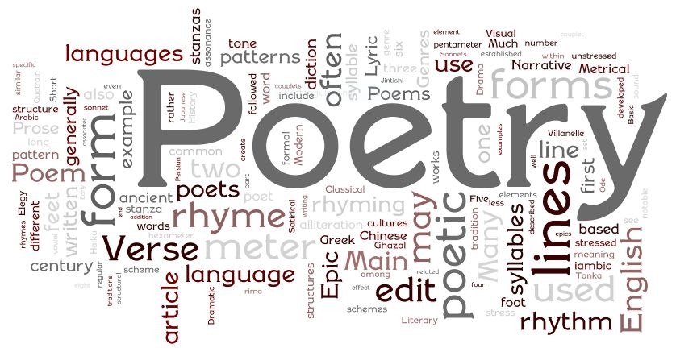
  - nature and poetry workshop
  - university of leeds
  - date: 26th MAY 2021
  - time: 02:00 PM BST London
  - Martin Veiga: – Galician poetry
  - Ricardo Michue-Bendezu: – environmental songs from Latin America
  - Tim Thurston: – Tibetan poetry
  - Mike Edwards: – Australia
  - Sam Liebhaber: – Mehri poetry, Yemen
  - Mary Mulholland:– Caribbean
  - rob MILES: - british isle encounters: three english poems

